Hyper-V 2012 Management Pack Extensions

#### Authors: Cristian Edwards and Diego Martinez Rellan (Microsoft Premier Field Engineers)

#### **This Hyper-V 2012 Management Pack Extension is intended to add performance monitoring to the existing Hyper-v Management Pack.**

#### **This MP has monitors, rules and views that are detailed below. To avoid huge database consumption all rules are disabled by default. You can use these rules for creating your environment baselines.**

#### **Monitors are enabled and ready to run on your SCOM environment.**

**The configured thresholds on the monitors should cover most common scenarios but you may need to tune some of them to cover your own needs.**

**This MP is provided “as is” without any official support from Microsoft.**

# Installing Hyper-V 2012 Management Pack Extensions

### Requirements

* SCOM 2012 RTM or SCOM 2012 SP1
* Windows OS Management Pack 6.0.6989.0 or higher.  
  <http://www.microsoft.com/download/en/details.aspx?id=9296>  
    
  System Center 2012 Management Pack for Windows Server Hyper-V 2012 6.2.6640.0 or higher.  
  <http://www.microsoft.com/en-us/download/details.aspx?id=36438>  
    
  System Center Management Pack for Windows Server Cluster 6.0.7005.0 or higher.  
  <http://www.microsoft.com/download/en/details.aspx?id=2268>

### HyperVMPE2012.mp references



### HyperVMPE2012.Dashboards.mp



# New Monitors and State Views included on this release

### Hyper-V Replica State Views and Dashboard

These State Views and the Dashboard enhances the information displayed in SCOM 2012 to monitor the Hyper-V Replica VMs. The health monitors are inherit from the official Management Pack for Hyper-V 2012



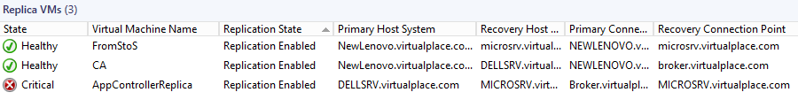

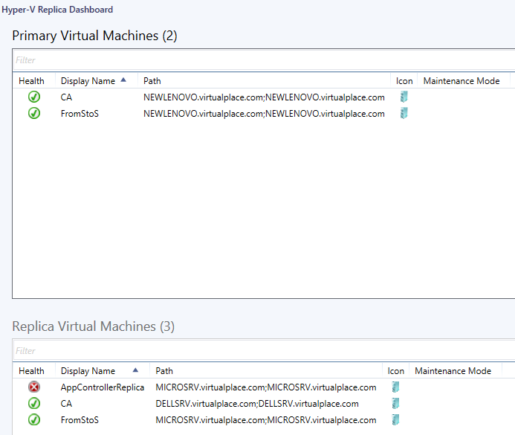

### Hyper-V Integration Services Version Monitor

This Monitor uses Ben Armstrong’s Powershell Script documented here:

<http://blogs.msdn.com/b/virtual_pc_guy/archive/2013/04/29/powershell-script-to-tell-you-if-you-need-to-update-your-integration-services.aspx>

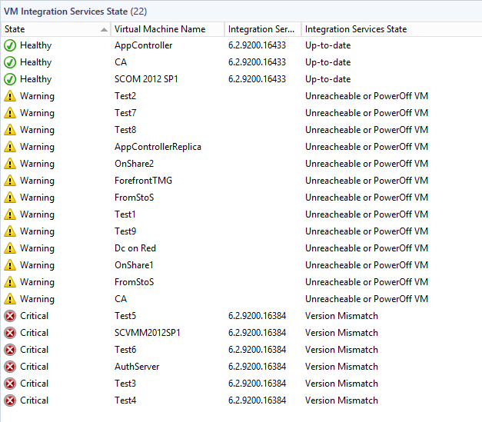

### Hyper-V SMB Client Shares Monitoring

This monitor evaluates the performance counter \SMB Client Shares(*)\Avg. sec/Data Request to detect if the latency is above 25 ms. You can find more information on Jose Barreto’s post <http://blogs.technet.com/b/josebda/archive/2013/03/28/sqlio-powershell-and-storage-performance-measuring-iops-throughput-and-latency-for-both-local-disks-and-smb-file-shares.aspx>

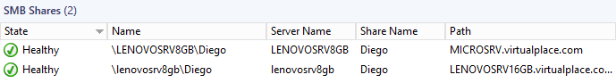

# Configuring Hyper-V 2012 Management Pack Extensions Monitors:

By default all monitors except the “Hyper-V Virtual Machine Summary (Stopped VMs)” are enabled. The configured monitors are optimized to avoid high network utilization and to detect most common performance problems without generating too much alerts. The way we achieve that is creating consecutive samples monitors. This will ensure that alerts are only generated after some samples that are above the threshold in a period of time. The SCOM agents will upload the information to the SCOM server only when the alerts conditions are met. If no issue is detected the SCOM agent will not upload the data to the SCOM server optimizing the network utilization.

If default thresholds are not meeting your requirements you will need to adjust the number of samples, the frequency and maybe the thresholds. Remember that these monitors are created to cover the most common performance problems scenarios.

We highly recommend to override the MP if you need to change the default monitors configuration. This will ensure that your changes remain if a new version of this MP is released.

Finally remember that monitors information is not saved in the SQL database by default to generate reports. You should use the Rules on this MP if your intention is to create your environment performance baseline

The following table shows the monitors configuration:

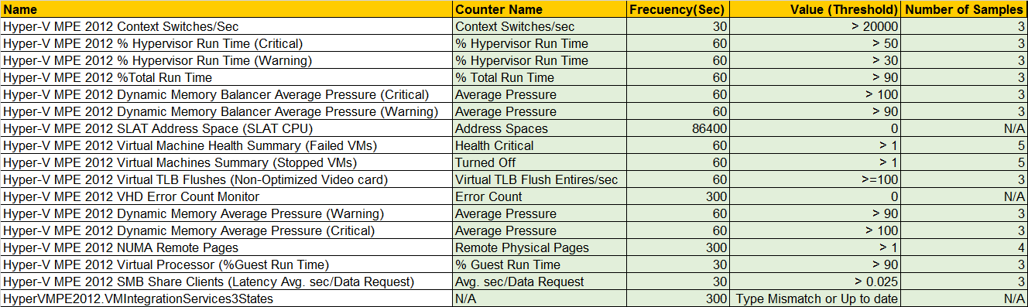

# Monitors details

|  |  |
| --- | --- |
| **Monitor name** | Memory Available Mbytes |
| **Type** | UnitMonitor |
| **Category** | PerformanceHealth |
| **Description** | Available MBytes is the amount of physical RAM, in Megabytes, immediately available for allocation to a process or for system use. It is equal to the sum of memory assigned to the standby (cached), free and zero page lists. If this counter is low, then the computer is running low on physical RAM.  RAM resource required by Virtual Machines should not exceed the Amount of physical RAM on the host - Host reserve.  *Host reserve in a non-dynamic memory configuration depends on the parent partition Operating System version and is defined as follows*  Host Reserve for Windows 2008 / 2008 R2 Core Edition is 300 MB for Hypervisor + 512 MB for parent partition + VM overhead  Host Reserve for Windows 2008 / 2008 R2 Full Edition is 300 MB for Hypervisor + 1024 MB for parent partition + VM overhead  Where VM Overhead is 32MB for the first 1GB of ram in each VM, plus 8MB for each subsequent GB of ram in each VM.  *Host reserve in a Dynamic Memory configuration is defined as follows*  In summary, the default value for this is calculated based on the following formula:  **384MB + 30MB per 1GB** of physical memory on the host machine.  (For a machine without SLAT (Second Level Address Translation) enabled CPUs, it is slightly higher)  So for my SLAT enabled Hyper-V server with 64GB RAM, this would mean the default value is:  **384 + (30 * 64) = 2304 (MB)**  <http://blogs.technet.com/b/virtualpfe/archive/2011/08/29/hyper-v-dynamic-memory-and-host-memory-reserve-setting.aspx> |

|  |  |
| --- | --- |
| **Monitor name** | Hyper-V Virtual Storage Error Count (on each VHD file) |
| **Type** | UnitMonitor |
| **Category** | PerformanceHealth |
| **Description** | There are two Hyper-V storage counter sets because of how storage works in Hyper-V. In Hyper-V we provide two virtual storage buses for VM’s. One is IDE and one is SCSI. The Virtual IDE counters show up in the “Hyper-V Virtual IDE Controller” counter set unless Integration Services are loaded and then you will see the activity for both virtual IDE and SCSI in the “Hyper-V Virtual Storage Device” counter set. If you don’t have integration services installed the only the “Hyper-V Virtual IDE Controller” will show the VM disk activity.  The Error count should always be zero for the virtual storage device. |

|  |  |
| --- | --- |
| **Monitor name** | Dynamic Memory Balancer Avergage Pressure |
| **Type** | UnitMonitor |
| **Category** | PerformanceHealth |
| **Description** | This gives you a very simple view of the overall memory allocation of your system. As long as this counter is under 100, there is enough memory in your system to service your virtual machines. Ideally this value should be at 80 or lower. The closer this gets to 100, the closer you are to running out of memory. Once this number goes over 100 then you can pretty much guarantee that you have virtual machines that are paging in the guest operating system.  <http://blogs.msdn.com/b/virtual_pc_guy/archive/2010/09/01/looking-at-dynamic-memory-performance-counters.aspx> |

|  |  |
| --- | --- |
| **Monitor** | Dynamic Memory Virtual Machine Average Pressure |
| **Type** | UnitMonitor |
| **Category** | PerformanceHealth |
| **Description** | A virtual machine with a pressure of 100 has exactly the amount of memory that it needs (this is equivalent to a memory availability of 0%). If the virtual machine pressure goes over 100 it has less memory than it needs (equivalent to a negative memory availability) and if the virtual machine pressure is under 100 then the virtual machine has more memory than it needs.  <http://blogs.msdn.com/b/virtual_pc_guy/archive/2010/09/01/looking-at-dynamic-memory-performance-counters.aspx> |

|  |  |
| --- | --- |
| **Monitor** | Network Interface Output Queue Length |
| **Type** | UnitMonitor |
| **Category** | PerformanceHealth |
| **Description** | The output queue length measures the number of threads waiting on the network adapter. If there are more than 2 threads waiting on the network adapter, then the network may be a bottleneck. Common causes of this are poor network latency and/or high collision rates on the network. If this is longer than two, there are delays and the bottleneck should be found and eliminated, if possible. Since the requests are queued by the Network Driver Interface Specification (NDIS) in this implementation, this will always be 0.”  • Use the following thresholds to evaluate output queue length: • 0 = Healthy • 1-2 = Monitor or Caution • Greater than 2 = Critical, performance will be adversely affected Note: This counter does not work (always 0) in Windows Server 2008 R2 or Windows 7. Use Resource Monitor for packet loss and latency—see note below. |

|  |  |
| --- | --- |
| **Monitor** | SLAT Address Space (SLAT CPU) |
| **Type** | UnitMonitor |
| **Category** | PerformanceHealth |
| **Description** | Windows Server 2008 R2 Hyper-V supports a new feature named Second Level Address Translation (SLAT). SLAT leverages AMD-V Rapid Virtualization Indexing (RVI) and Intel VT Extended Page Tables (NPT) technology to reduce the overhead incurred during virtual to physical address mapping performed for virtual machines. Through RVI or EPT respectively, AMD-V and Intel VT processors maintain address mappings and perform (in hardware) the two levels of address space translations required for each virtual machine, reducing the complexity of the Windows hypervisor and the context switches needed to manage virtual machine page faults. With SLAT, the Windows hypervisor does not need to shadow the guest operating system page mappings. The reduction in processor and memory overhead associated with SLAT improves scalability with respect to the number of virtual machines that can be concurrently executed on a single Hyper-V server. As an example, the Microsoft Remote Desktop Services (RDS) team recently blogged about performance tests conducted using an internal simulation tool on a Windows Server 2008 Terminal Services configuration running as a virtual machine on Windows Server 2008 R2 Hyper-V. The results showed that a SLAT-enabled processor platform increased the number of supported sessions by a factor of 1.6 to 2.5 when compared with a non-SLAT processor platform. Overall, Microsoft reports that with SLAT-enabled processors, the Windows hypervisor processor overhead drops from about 10% to about 2%, and reduces memory usage by about 1 MB for each virtual machine.  <http://www.virtualizationadmin.com/articles-tutorials/microsoft-hyper-v-articles/general/second-level-address-translation-benefits-hyper-v-r2.html> |

|  |  |
| --- | --- |
| **Monitor** | Logical Disk Seconds per Read |
| **Type** | UnitMonitor |
| **Category** | PerformanceHealth |
| **Description** | Description: Avg. Disk sec/Read is the average time, in seconds, of a read of data to the disk. This analysis determines if any of the physical disks are responding slowly. If the response times are greater than .015 (15 milliseconds), then the disk subsystem is keeping up with demand, but does not have much overhead left. If the response times are greater than .025 (25 milliseconds), then noticeable slow downs and performance issues affecting users may be occurring. |

|  |  |
| --- | --- |
| **Monitor** | Logical Disk Seconds per Write |
| **Type** | UnitMonitor |
| **Category** | PerformanceHealth |
| **Description** | Description: Avg. Disk sec/Write is the average time, in seconds, of a write of data to the disk. This analysis determines if any of the physical disks are responding slowly. If the response times are greater than .015 (15 milliseconds), then the disk subsystem is keeping up with demand, but does not have much overhead left. If the response times are greater than .025 (25 milliseconds), then noticeable slow downs and performance issues affecting users may be occurring. |

|  |  |
| --- | --- |
| **Monitor** | Logical Disk (Current Disk Queue Length) |
| **Type** | UnitMonitor |
| **Category** | PerformanceHealth |
| **Description** | The number of waiting I/O requests should be sustained at no more than 1.5 to 2 times the number of spindles that make up the physical disk. Most disks have one spindle, although redundant array of independent disk (RAID) devices usually have more than one spindle. A hardware RAID device appears as one physical disk in System Monitor. RAID devices created through software appear as multiple instances in System Monitor.Use the values of the **Current Disk Queue Length** and **% Disk Time** counters to detect bottlenecks within the disk subsystem. If **Current Disk Queue Length** and **% Disk Time** counter values are consistently high, consider doing one of the following:   * Using a faster disk drive. * Moving some files to an additional disk or server. * Adding disks to a RAID array, if one is being used.   If you are using a RAID device, the **% Disk Time** counter can indicate a value greater than 100 percent. If it does, use the **Avg. Disk Queue Length** counter to determine how many system requests, on average, are waiting for disk access.  Applications and systems that are I/O-bound may keep the disk constantly active. |

|  |  |
| --- | --- |
| **Monitor** | Physical Disk Seconds Per Read |
| **Type** | UnitMonitor |
| **Category** | PerformanceHealth |
| **Description** | Description: Avg. Disk sec/Read is the average time, in seconds, of a read of data to the disk. This analysis determines if any of the physical disks are responding slowly. If the response times are greater than .015 (15 milliseconds), then the disk subsystem is keeping up with demand, but does not have much overhead left. If the response times are greater than .025 (25 milliseconds), then noticeable slow downs and performance issues affecting users may be occurring. |

|  |  |
| --- | --- |
| **Monitor** | Physical Disk Seconds Per Write |
| **Type** | UnitMonitor |
| **Category** | PerformanceHealth |
| **Description** | Description: Avg. Disk sec/Write is the average time, in seconds, of a write of data to the disk. This analysis determines if any of the physical disks are responding slowly. If the response times are greater than .015 (15 milliseconds), then the disk subsystem is keeping up with demand, but does not have much overhead left. If the response times are greater than .025 (25 milliseconds), then noticeable slow downs and performance issues affecting users may be occurring. |

|  |  |
| --- | --- |
| **Monitor** | Physical Disk (Current Disk Queue Length) |
| **Type** | UnitMonitor |
| **Category** | PerformanceHealth |
| **Description** | The number of waiting I/O requests should be sustained at no more than 1.5 to 2 times the number of spindles that make up the physical disk. Most disks have one spindle, although redundant array of independent disk (RAID) devices usually have more than one spindle. A hardware RAID device appears as one physical disk in System Monitor. RAID devices created through software appear as multiple instances in System Monitor.Use the values of the **Current Disk Queue Length** and **% Disk Time** counters to detect bottlenecks within the disk subsystem. If **Current Disk Queue Length** and **% Disk Time** counter values are consistently high, consider doing one of the following:   * Using a faster disk drive. * Moving some files to an additional disk or server. * Adding disks to a RAID array, if one is being used.   If you are using a RAID device, the **% Disk Time** counter can indicate a value greater than 100 percent. If it does, use the **Avg. Disk Queue Length** counter to determine how many system requests, on average, are waiting for disk access.  Applications and systems that are I/O-bound may keep the disk constantly active. |

|  |  |
| --- | --- |
| **Monitor** | Hyper-V Virtual Machine Summary (Stopped VMs) |
| **Type** | UnitMonitor |
| **Category** | AvailabilityHealth |
| **Description** | This monitor detects if your VMs are stopped or not. In some scenarios you will want to be sure that your VMs are always running |

|  |  |
| --- | --- |
| **Monitor** | Hyper-V Virtual Machine Health Summary (Failed VMs) |
| **Type** | UnitMonitor |
| **Category** | AvailabilityHealth |
| **Description** | This monitor detects if your VMs are in failed state |

|  |  |
| --- | --- |
| **Monitor** | Virtual TLB Flushes (Non-Optimized Video card) |
| **Type** | UnitMonitor |
| **Category** | PerformanceHealth |
| **Description** | Video card drivers tend to use memory access methods that cause Hyper-V to need to clear out the CPU cache for memory page table mapping a lot. This is an expensive thing to do in Hyper-V at the best of times.  <http://blogs.msdn.com/b/virtual_pc_guy/archive/2009/11/16/understanding-high-end-video-performance-issues-with-hyper-v.aspx> |

|  |  |
| --- | --- |
| **Monitor** | Hyper-V Logical Processor (%Total Run Time) |
| **Type** | UnitMonitor |
| **Category** | PerformanceHealth |
| **Modified** | This analysis checks the processor utilization of physical processors of the host computer. The "\Hyper-V Hypervisor Logical Processor(*)\% Total Run Time" performance counter is more accurate than using the "% Processor Time" counter on the host, root partition computer because the "% Processor Time" counter only measures the processor time of the host, root partition computer only. The "\Hyper-V Hypervisor Logical Processor(*)\% Total Run Time" performance counter is the best counter to use to analyze overall processor utilization of the Hyper-V server. |

|  |  |
| --- | --- |
| **Monitor** | Hyper-V Logical Processor (%Hypervisor RunTime) Critical |
| **Type** | UnitMonitor |
| **Category** | PerformanceHealth |
| **Description** | For guest VM’s this is the percentage of time the guest VP is running in hypervisor code on an LP or for the _Total the total across all guest VP’s. For the root this is the percentage of time the root VP is running in hypervisor code on an LP |

|  |  |
| --- | --- |
| **Monitor** | Hyper-V Logical Processor (%Hypervisor RunTime) Warning |
| **Type** | UnitMonitor |
| **Category** | PerformanceHealth |
| **Description** | For guest VM’s this is the percentage of time the guest VP is running in hypervisor code on an LP or for the _Total the total across all guest VP’s. For the root this is the percentage of time the root VP is running in hypervisor code on an LP |

|  |  |
| --- | --- |
| **Monitor** | Hyper-V Virtual Processor (%Guest Run Time) |
| **Type** | UnitMonitor |
| **Category** | PerformanceHealth |
| **Description** | This monitor checks the processor utilization of guest, virtual computer processors. The "\Hyper-V Hypervisor Virtual Processor(*)\% Guest Run Time" performance counter is more accurate than using the "% Processor Time" counter within the virtual computer due to clock calculation drift. |

|  |  |
| --- | --- |
| **Monitor** | Hyper-V Logical Processor (Context Switches/Sec) |
| **Type** | UnitMonitor |
| **Category** | PerformanceHealth |
| **Description** | It is the number of context switches made for switching out/in the VM Virtual Processors. This does not keep into account the number of context switches made by the threads running in the host Operating System. |

|  |  |
| --- | --- |
| **Monitor** | NUMA Remote Pages |
| **Type** | UnitMonitor |
| **Category** | PerformanceHealth |
| **Description** | Top of Form  Every VM in Hyper-V has a default NUMA node preference. Hyper-V uses this NUMA node preference when assigning physical memory to the VM and when scheduling the VM’s virtual processors. A VM runs best when the virtual processors and the memory that backs the VM are both on the same NUMA node, since such “remote” memory access is significantly slower than “local” access  Bottom of Form |

# Rules details

The intention of this MP is not only to monitor the performance for troubleshooting purposes. Rules included in this MP will help you create you Hyper-V hosts performance baselines. All rules are disabled by default because they could impact the network performance.

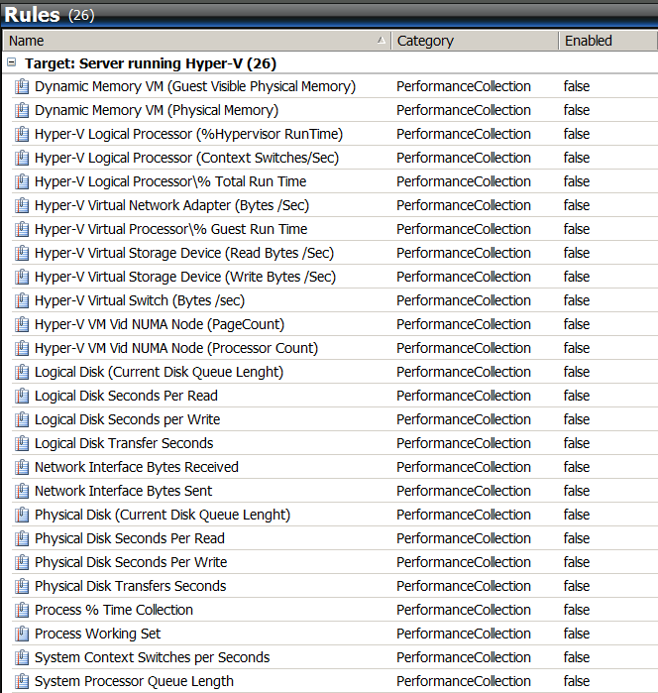

# Views

# 

# 